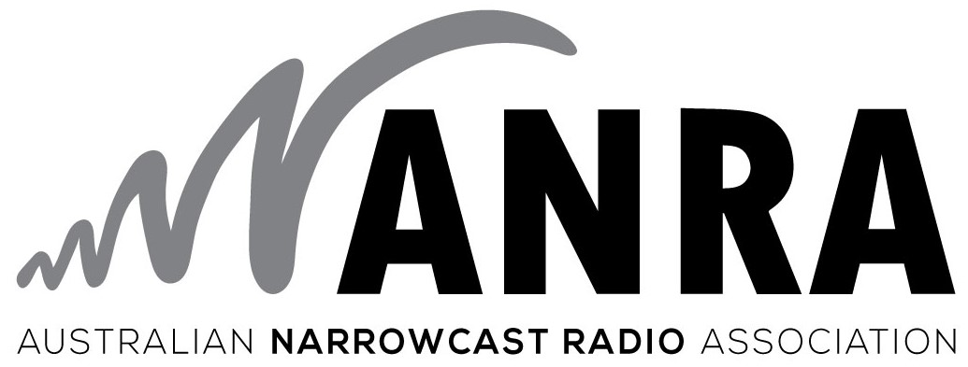

Response to

EXTENDING THE
AVAILABILITY OF SPECTRUM
FOR LPONS

ANRA welcomes the opportunity to respond to provide a submission that supports the ACMA's proposal to extend the availability of spectrum for LPON services until 31 December 2025.

Our comments reflect a consensus of our membership. However individual members may make their own submissions.

ANRA, the Australian Narrowcast Radio Association, is the peak industry body representing Low Power Open Narrowcast (LPON) Radio services and High Power Open Narrowcast (HPON) Radio services located across all States and Territories of Australia. Our membership includes the major Narrowcast radio program providers such as the TAB agencies and organisations, foreign language groups, fringe music services, tourist services and religious services, as well as many other independently owned and operated services. Narrowcast Radio in Australia now accounts for ten times more licenses issued than those from the Commercial and Community sectors and is continually growing. ANRA also encourages greater diversity and opportunities within the broadcasting sector.

ANRA appreciates the prompt action taken by the ACMA in addressing the concerns raised by the Narrowcasting Industry regarding the provision for sufficient certainty of access to spectrum to facilitate forward business planning, as expressed in the Draft Five Year Spectrum Outlook 2018-22.
Therefore ANRA supports the ACMA's proposal to extend the availability of spectrum for LPON services until 31 December 2025 as a prudent interim measure to give certainty for Narrowcast operators while the impact of proposed changes to the Radiocommunications Act are fully considered.

ANRA continues to participate in regular discussions with the ACMA in regard to any changes to LPON and HPON conditions that may take place as part of the development of a licence product for open narrowcasting under the new Act.

These discussions are continuing to work towards a more flexible regime, and provide narrowcast operators with greater confidence to invest in longer term business plans and employment opportunities.

Concluding Comments:
ANRA appreciates being part of the process of consultation and encourages a collaborative approach between the different sectors of Radio broadcasting.
Our members thank the Authority for the opportunity to comment and support the proposal to extend the availability of spectrum for LPON services to 31 December 2025 and look forward to a continuing and positive dialogue.

Phil Edwards Angelo Nacson
President Secretary
Australian Narrowcast Radio Assn Australian Narrowcast Radio Assn
13.07.2018 13.07.2018

